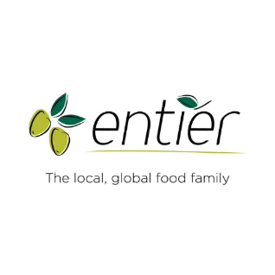
North East Chef of the Year 2024
Application Form (closing date – 25th March)
Applicant
Name: D.O.B.
Address: Postcode:
Email: Contact No:

Employer:
Employer Address: Postcode:

Categories: (please tick appropriate)
Chef of the Year £40 Young Chef of the Year £0 (sponsored by Entier)
Seafood Chef of the Year £30 (22 years and under)

Menu
Please attached your proposed menu as a word document, noting the full menu planned, the ingredients used and the full method. Please also attach photographs of the finished dishes.

Supplier
Please provide the full name and address of all suppliers used (this can be submitted as a separate word document as per above)

How many evening dinner tickets are required? (Note – all finalists will receive their evening dinner included in their application):

Payment Information: (Payment via BACS is preferred) –
Payment is required upon submission of application, otherwise the application will not be accepted.
Bank of Scotland
Sort Code: 80-06-19 A/C No: 00413445
A/C Name: Hospitality Training Please quote your full name as the reference

