North East of Scotland Restaurant of the Year & Casual Dining Award 2024

Application Requirements
1.Fill in and complete the application form available on our website and submit payment of the application fee: -
Restaurant of The Year - £150.00
Casual Dining Award - £150.00

2.Provide a full copy of your current menu and wine List.
3.Provide a description of your business, to include: -
- How you are supporting the use of Scottish seasonal produce
- Your service style and commitment to the diner experience
- How many covers you cater for
- Opening / closing times
- Set meal times

4.Once the competition opens, you will be provided with a link to the competition poll on our website, which will run for 2 weeks. We want your customers to vote for your establishments.

5.When the customer voting has closed on Friday 12th April, the finalists with the most customer votes will be contacted and invited to the next stage.

6. The finalist establishments will be then judged by unannounced inspection.

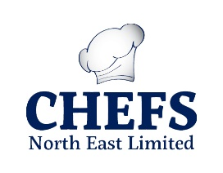
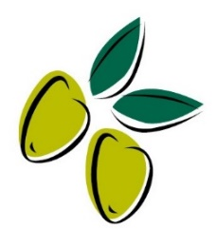
7. Winners will be announced at the awards ceremony at the Chester Hotel on Monday 20th May. Dinner tickets cost £75 per person.

